COMPENSATION OF ROTARY AXES IN A MACHINE TOOL

June 7/8 2000

The purpose of the measurement was to test and compensate the B and C rotary axis of a machine tool.
One for a full revolution the other for 180 Deg only.
Was used MCV 4000 with automatic rotary table Software LDDM 2.31 and WinPipe 3.10
The numerical control of the machine is Siemens 840D
The first measurement was taken on the C rotary axis without compensation table, the axis movement is defined as –180 -+180 Deg. The file error file generated by the LDDM analysis software after the measurement was processed by the software WinPipe and was automatically generated the compensation file in the format for the CNC controller

The error before compensation is illustrated in the following figure: +3 to –24 thousandth of deg.

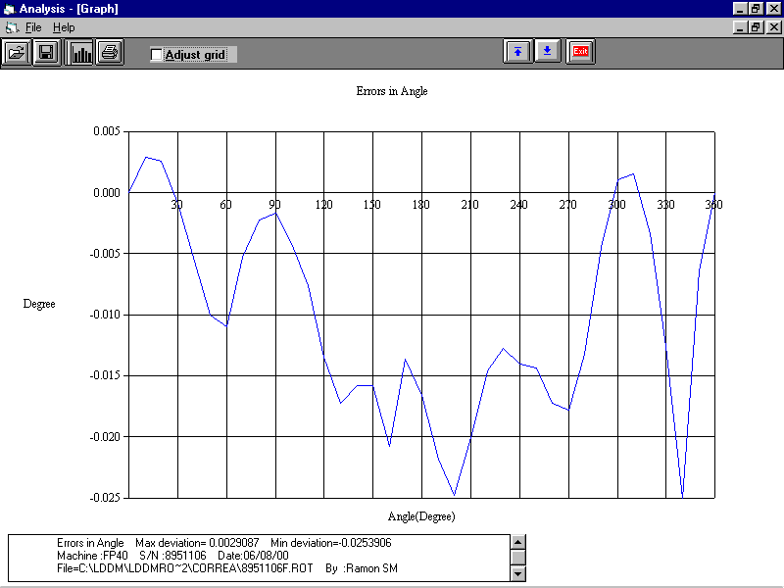
The file generated By WinPipe software compatible with the Siemens CNC is the following:

%_N_COMP_AX_EEC
;$PATH=/_N_MPF_DIR
$MA_ENC_COMP_ENABLE[1,AC1]=0
newconf
stopre
$AA_ENC_COMP[1,0,AC1]=0.00000000
$AA_ENC_COMP[1,1,AC1]=0.00290840
$AA_ENC_COMP[1,2,AC1]=0.00262010
$AA_ENC_COMP[1,3,AC1]=-0.00086210
$AA_ENC_COMP[1,4,AC1]=-0.00566680
$AA_ENC_COMP[1,5,AC1]=-0.01021730
$AA_ENC_COMP[1,6,AC1]=-0.01119420
$AA_ENC_COMP[1,7,AC1]=-0.00538500
$AA_ENC_COMP[1,8,AC1]=-0.00224390
$AA_ENC_COMP[1,9,AC1]=-0.00167620
$AA_ENC_COMP[1,10,AC1]=-0.00425800
$AA_ENC_COMP[1,11,AC1]=-0.00777010
$AA_ENC_COMP[1,12,AC1]=-0.01372390
$AA_ENC_COMP[1,13,AC1]=-0.01752410
$AA_ENC_COMP[1,14,AC1]=-0.01604840
$AA_ENC_COMP[1,15,AC1]=-0.01606960
$AA_ENC_COMP[1,16,AC1]=-0.02114150
$AA_ENC_COMP[1,17,AC1]=-0.01384140
$AA_ENC_COMP[1,18,AC1]=-0.01685630
$AA_ENC_COMP[1,19,AC1]=-0.02218340

$AA_ENC_COMP[1,20,AC1]=-0.02519320
$AA_ENC_COMP[1,21,AC1]=-0.02034950
$AA_ENC_COMP[1,22,AC1]=-0.01485740
$AA_ENC_COMP[1,23,AC1]=-0.01298180
$AA_ENC_COMP[1,24,AC1]=-0.01429790
$AA_ENC_COMP[1,25,AC1]=-0.01459430
$AA_ENC_COMP[1,26,AC1]=-0.01751530
$AA_ENC_COMP[1,27,AC1]=-0.01809110
$AA_ENC_COMP[1,28,AC1]=-0.01344450
$AA_ENC_COMP[1,29,AC1]=-0.00456840
$AA_ENC_COMP[1,30,AC1]=0.00109630
$AA_ENC_COMP[1,31,AC1]=0.00159040
$AA_ENC_COMP[1,32,AC1]=-0.00345410
$AA_ENC_COMP[1,33,AC1]=-0.01279350
$AA_ENC_COMP[1,34,AC1]=-0.02540540
$AA_ENC_COMP[1,35,AC1]=-0.00653480
$AA_ENC_COMP[1,36,AC1]=0.00002040
$AA_ENC_COMP_STEP[1,AC1]=10.00000000
$AA_ENC_COMP_MIN[1,AC1]=-180.00000000
$AA_ENC_COMP_MAX[1,AC1]=180.00000000
$AA_ENC_COMP_IS_MODULO[1,AC1]=0
$MA_BACKLASH[1,AC1]=0.00000000
$MA_ENC_COMP_ENABLE[1,AC1]=1
newconf
stopre
M17

The file was directly loaded from the WinPipe program in the CNC by serial line.

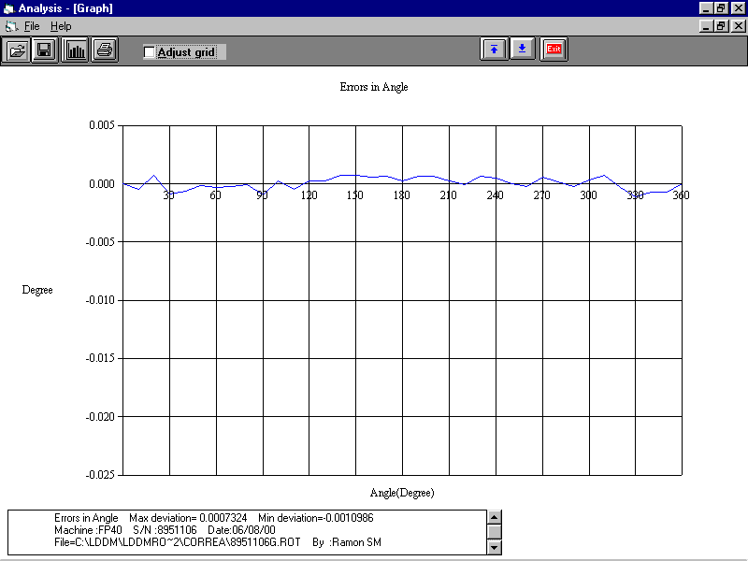
The Axis was measured after the error compensation and the error dropped to plus/minus 0.5 thousandth of deg.
Measure of the A axis for 180 Deg.

Was used the automatic rotary table mounted on a tool that was assuring that the machine axis, the automatic little rotary table and the dual retroreflector are centered better than .05mm.
The movement is between –90 (tool horizontal) to 0 (tool vertical) to + 90 deg (tool horizontal to the other side)

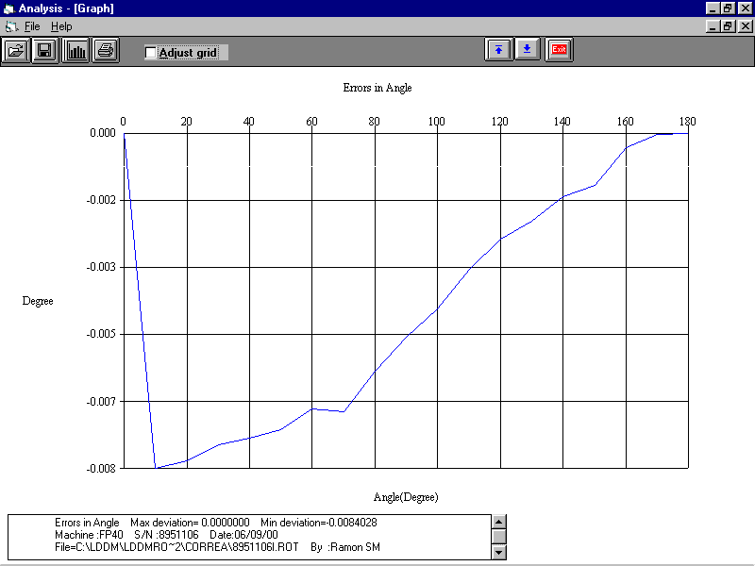
was collected the first file without any compensation ,starting –90 to +90 deg with the following results in the error file

Was generated the correction table using winpipe program introducing the reference point at 90 deg and the starting point at –90deg

the results of the compensation is below 1thousandt of deg.

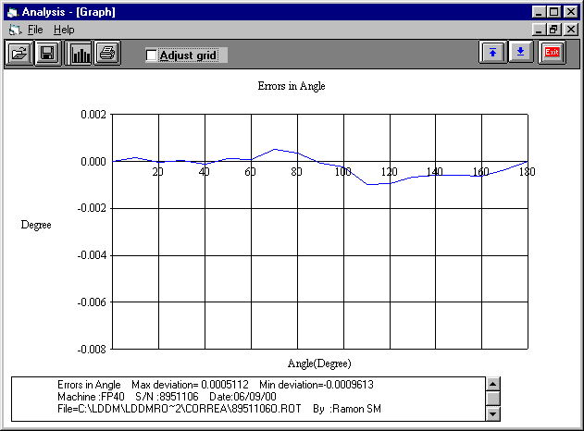

Both the axes was corrected in few hour

